AI-Driven Semantic Analysis for Automated Research Gap Identification

Namrata Vaidya
Dept. of Computer Science and Engineering
Symbiosis Institute of Technology
Nagpur, India
namrata.vaidya.batch2024@sitnagpur.siu.edu.in
Reshal Age
Dept. of Computer Science and Engineering
Symbiosis Institute of Technology
Nagpur, India
reshal.age.batch2024@sitnagpur.siu.edu.in
Ritika Bhoyar
Dept. of Computer Science and Engineering
Symbiosis Institute of Technology
Nagpur, India
ritika.bhoyar.batch2024@sitnagpur.siu.edu.in

Abstract—The rapid growth of scientific literature makes it hard for researchers to see what has been studied and which limitations remain, and keyword search cannot capture semantic relationships between studies. This paper presents ResearchLens AI, a prototype for automated research gap identification that combines semantic retrieval with rule-based limitation analysis. Metadata for 2,200 papers (220 in each of ten domains, published from January 2020 to May 2026) is collected from OpenAlex and encoded as 384-dimensional embeddings with the all-MiniLM-L6-v2 Sentence Transformer, and the application searches them with a FAISS index. A rule-based module detects 13 predefined limitation-pattern categories in the retrieved papers, aggregates them by frequency, and maps the most frequent category to a predefined research-direction recommendation. Sustainable Development Goal (SDG) labels are inherited from OpenAlex metadata. All components are integrated into a Streamlit dashboard. In a small retrieval benchmark of five domain-specific queries, the top 10 results of BM25 and semantic retrieval were pooled and judged manually from titles and abstracts. Semantic retrieval reached a mean Precision@10 of 0.26 against 0.20 for BM25. Over the three queries with at least one relevant paper in the pool, mean pooled Recall@10 was 0.905 against 0.578. BM25 performed better on one query, and neither method found a relevant paper for two queries. The limitation detector has not been validated against expert annotations, so its output shows detected limitation mentions, not confirmed research gaps. The study demonstrates a working workflow and a preliminary retrieval comparison, not a validated gap-identification benchmark.
Keywords—research gap identification, semantic search, BM25, sentence transformers, FAISS, OpenAlex, limitation detection, sustainable development goals, literature review automation

Introduction
Scientific output has grown at an unprecedented rate, with databases such as PubMed, IEEE Xplore, arXiv, and Scopus indexing millions of new papers every year. A researcher entering a domain may need to review hundreds or even thousands of papers to establish what has been studied and, most critically, what remains unexplored. Duplicated effort wastes time and funding, while genuinely novel directions can stay hidden because no one has had the time or tools to notice the gap. Literature-based discovery approaches [1] and frameworks for identifying research gaps from evidence syntheses [2] have been proposed to support this task, and a scoping review has mapped the methods used to identify, prioritize and display gaps in health research [3].
Conventional literature search relies on keyword matching, which fails to capture relationships between papers that use different terminology for related ideas, cannot infer relationships among authors, methods, and citations, and, most importantly, only helps researchers find related papers without reasoning about what is missing from the literature. Identifying a gap therefore still falls on the researcher’s manual judgment. Sentence embeddings, large language models (LLMs), and knowledge graphs offer an opportunity to address these limitations by representing conceptual rather than lexical similarity.
This paper presents ResearchLens AI, a prototype for automated research gap identification. The user enters a research topic, optionally scoped to a domain; papers from an OpenAlex-based corpus are retrieved by semantic similarity using Sentence Transformer embeddings; a rule-based module detects recurring limitation patterns in the retrieved papers and ranks them by observed frequency; and the system links the most frequent pattern to a predefined future-research recommendation and to Sustainable Development Goal (SDG) labels taken from OpenAlex metadata.
In this paper, a “research gap” is used in an operational sense: a limitation pattern that recurs across the retrieved papers. A detected limitation is not necessarily a novel or unresolved research gap, and the paper keeps the two apart. Existing tools tend to cover one or two stages, such as filtering papers, building knowledge graphs, or recommending related work. ResearchLens AI does not propose a new retrieval model or learning algorithm. Its contribution is to combine domain-filtered semantic retrieval, limitation detection, evidence aggregation, and recommendation in one explainable workflow, and to evaluate the retrieval part against a lexical baseline with clearly stated limits.
The study addresses two research questions. RQ1: Does semantic retrieval with all-MiniLM-L6-v2 return more relevant papers than BM25 when both rank the same candidate set? RQ2: How consistent is the difference between the two methods across domains?
The contributions are (i) a corpus of 2,200 OpenAlex papers across ten domains (220 per domain) with its construction documented; (ii) a pooled, manually judged comparison of BM25 and MiniLM-based semantic retrieval on five domain-specific queries, reporting Precision@10, pooled Recall@10, F1@10, and nDCG@10 together with their limits; (iii) a rule-based detector with 13 limitation categories whose output is kept separate from validated research gaps; and (iv) a Streamlit dashboard that shows supporting evidence with every output. Section II reviews related work, Section III describes the methodology, Section IV presents results, Section V discusses limitations, and Section VI concludes.

Literature Review
Nicholson and Greene review how biomedical knowledge graphs represent concepts and relationships as nodes and edges and how construction has moved from manual curation toward text mining; node embedding methods such as edge2vec outperform earlier workflows by modeling edge semantics [4]. Together with the wider knowledge graph literature [5], [6], this establishes the foundation for representing who studied what, yet most knowledge graph work concentrates on construction and enrichment, as in KARMA, which uses multi-agent LLMs to enrich knowledge graphs from PubMed articles [7], and only recent systems pair graphs or retrieval with explicit gap analysis [8].
LLMs have also been applied to the mechanics of review. LLMSurver, by Joos, Keim, and Fischer [9], uses LLMs as classification agents to filter large corpora; across more than 8,300 articles a consensus scheme kept recall above 98.8% while cutting filtering time from weeks to minutes. LitLLM [10] retrieves papers and drafts related-work text with retrieval-augmented generation, and keyphrase generation models [11] and earlier NLP-based knowledge extraction [12] compress the early stages of review as well. A systematic review of SLR automation covering 41 primary studies found that selection of primary studies is the most automated step and that no study applied automation to the planning and reporting phases [13].
Multi-agent systems split the task into specialized agents: a multi-agent SLR system [14] assigns separate agents to search-string generation, literature identification, data extraction, and data compilation, the last of which assesses trends and identifies gaps, and a multi-agent system for research gaps [15] detects and prioritizes candidate gaps, including a feasibility-aware prioritization step. The pattern generalizes beyond review, as in AgentsCourt for judicial reasoning [16] and KARMA for knowledge graph enrichment [7]. Because LLMs may hallucinate claims about what has or has not been studied, gap claims should be tied to retrieved evidence: LLMSurver [9] uses the LLM only to classify records as included or rejected and lets users inspect its outputs, and HySemRAG [8] grounds gap analysis in hybrid retrieval, a knowledge graph, and post-hoc citation verification.
Overall, existing systems specialize in a few stages: filtration tools [9] and review generators [10] address screening and writing, and a systematic review of SLR automation reports that planning and reporting remain unautomated [13]. Recent LLM-based systems do target gaps directly, such as HySemRAG for methodological gaps [8] and a multi-agent system for detecting and prioritizing research gaps [15]. In the studies we could verify, gap identification is demonstrated rather than quantitatively validated: HySemRAG reports extraction and citation accuracy but no accuracy for the gaps it identifies, and the multi-agent SLR system [14] reports only user feedback from ten researchers. In the sources we could access, none of the reviewed systems describes linking detected gaps to Sustainable Development Goals. ResearchLens AI does not close the validation gap itself, because its limitation detector is also unvalidated. Its contribution is a lightweight, explainable workflow over abstract-level metadata that keeps detected limitations separate from validated research gaps and evaluates its retrieval stage against a BM25 baseline. Table I compares the reviewed systems on the capabilities relevant to this work.
- Capability Comparison of Related Systems
System | Semantic retrieval | Gap detection | Gap ranking | Recommendation | SDG link | Traceable evidence | Validation (scope)
Joos et al. (2025) [9], LLMSurver | ✘ (LLM classification) | ✘ | ✘ | ✘ | ✘ | ◐ human inspects outputs | ✔ 8.3k articles, recall >98.8%; one SLR
Agarwal et al. (2024) [10], LitLLM | ◐ keyword search + LLM re-ranking | ✘ | ✘ | ✘ | ✘ | ✔ cited related-work text | ? not verified
Sami et al. (2024) [14], multi-agent SLR | ✘ (LLM search string and filtering) | ◐ one agent identifies gaps; method not detailed | ✘ | ✘ | ✘ | ◐ answers per research question in tables | ✘ feedback from 10 researchers only
Lu et al. (2025) [7], KARMA | ✘ | ✘ (KG enrichment) | ✘ | ✘ | ✘ | ◐ cross-agent verification | ✔ 1,200 PubMed articles, 3 domains; 83.1% LLM-verified
Godinez (2025) [8], HySemRAG | ✔ semantic + keyword + KG traversal | ◐ methodological gaps via topics and KG queries | ✘ | ✘ | ✘ | ✔ citation verification | ◐ extraction and citation accuracy; gaps not validated; one-domain demo
Silva et al. (2026) [15] | ? | ✔ | ✔ feasibility-aware | ? | ? | ? | ? (full text not accessed)
ResearchLens AI (this work) | ✔ MiniLM + FAISS | ◐ 13 rule-based categories, unvalidated | ◐ by frequency only | ◐ predefined mappings | ◐ from OpenAlex, not validated | ✔ supporting papers shown | ◐ retrieval only: 5 queries; gap detector unvalidated
✔ = described in the paper; ◐ = partial; ✘ = not described in the paper; ? = not verified. Surveys and foundational works [3]–[6], [13] are discussed in the text.

Methodology
Research paper representations are generated using the all-MiniLM-L6-v2 Sentence Transformer model. For each paper, the Title, Abstract, Topics, and Keywords fields are concatenated into a single text input, with missing values replaced by empty strings. The model generates normalized 384-dimensional embeddings using the normalize_embeddings = True parameter. The resulting embedding artifact contains 2,200 paper representations. To verify reproducibility, the embeddings were regenerated using the same dataset and current embedding-generation script. The regenerated and original embedding arrays were exactly identical, with matching paper IDs and dimensions and a maximum absolute difference of 0.0. Both artifacts had a mean L2 norm of 1.0. Generation details, including the model configuration and dataset and artifact SHA-256 hashes, were recorded in models/embeddings_metadata.json.
ResearchLens AI is an end-to-end framework that first retrieves the papers semantically relevant to the user’s topic and then performs gap analysis on this subset rather than on every publication, which keeps the analysis topic-specific and evidence-oriented. Fig. 1 shows the architecture.
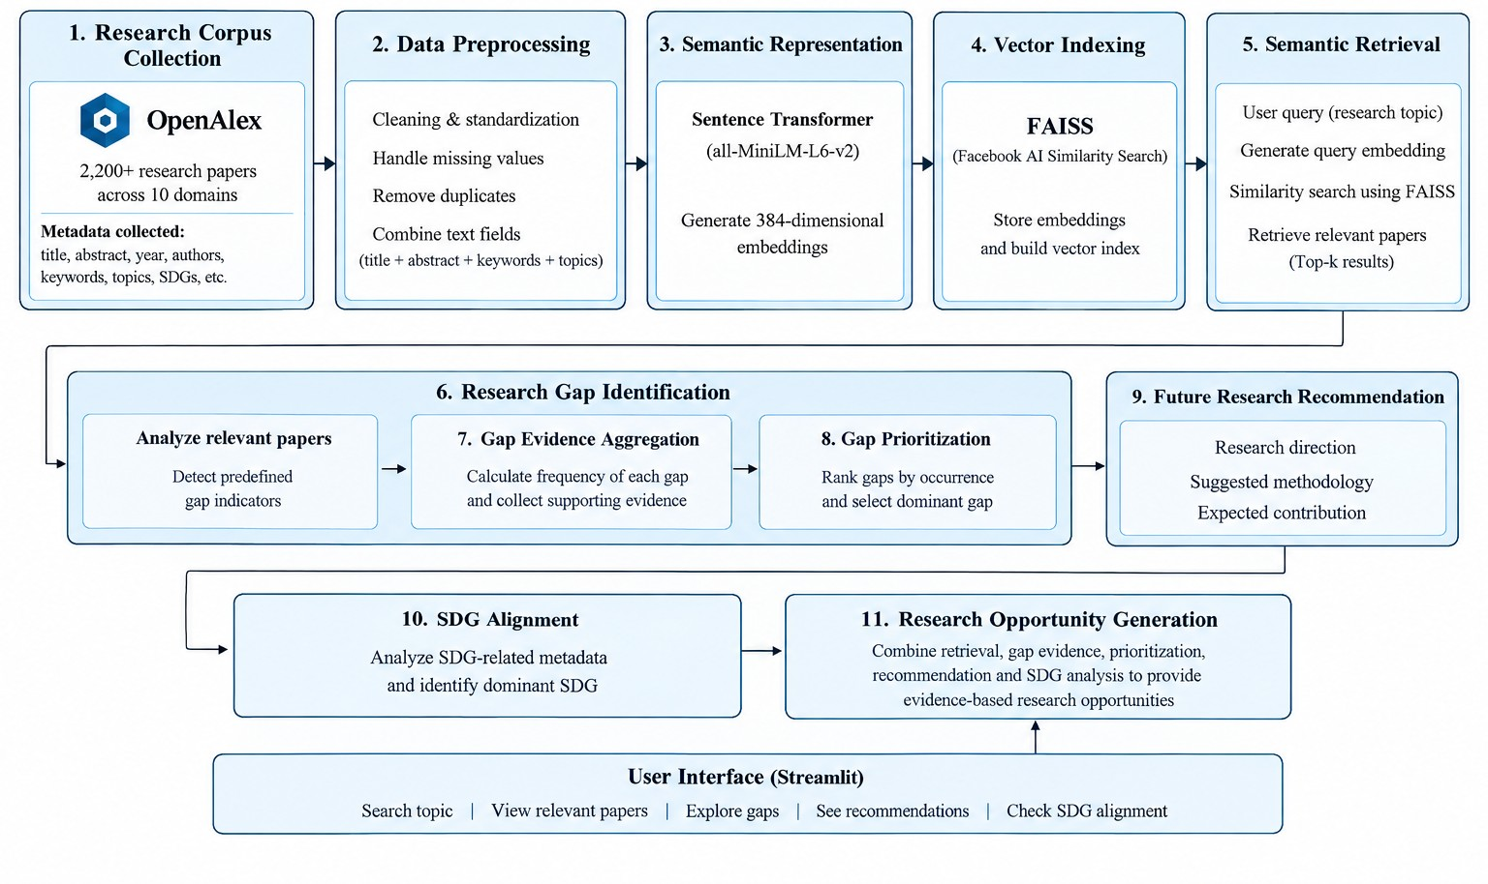
- Overall architecture of the proposed ResearchLens AI system.

Corpus Collection and Preprocessing
Publication metadata is collected from OpenAlex [17], [18]. The corpus holds 2,200 papers, 220 in each of 10 domains: Agriculture, Computer Science, Economics and Finance, Education, Energy, Engineering, Environmental Science, Healthcare, Materials Science, and Social Sciences. Publication dates range from 1 January 2020 to 20 May 2026. Each record keeps its title, abstract, year, authors, keywords, topics, domain, and SDG information; every record has an abstract and keywords, and 783 records (35.6%) carry no SDG label. Records are cleaned and standardized, and no OpenAlex paper ID appears twice in the corpus, although 30 records repeat the title of another record and 3 of these also repeat its abstract. The title, abstract, keywords, and topics are combined into one text field, since the same concept may be worded differently across them.

Semantic Representation and Indexing
The combined text of each paper is converted to a 384-dimensional vector with the all-MiniLM-L6-v2 Sentence Transformer model [19], [20], so conceptually related papers match even without shared keywords; for example, “AI for disease detection” can retrieve work on machine learning for diagnosis. The embeddings are stored in a FAISS index [21] for fast similarity search (Fig. 2).
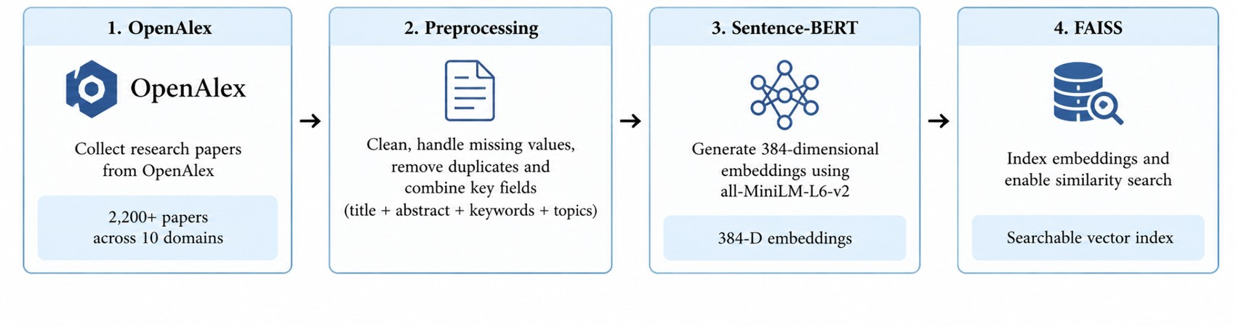
- Semantic research paper retrieval pipeline: OpenAlex, preprocessing, Sentence-BERT, and FAISS.

Query Processing and Retrieval
A user query is encoded by the same model and compared with the FAISS index, and the most similar papers form the relevant subset for that topic. Gap analysis is thus not run blindly over the whole corpus: a disease detection topic prioritizes healthcare papers instead of unrelated agriculture, economics, or education work (Fig. 3).
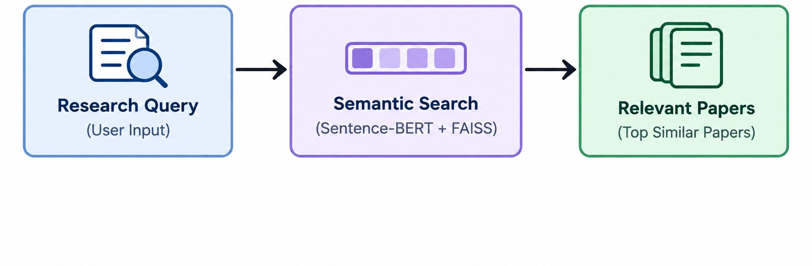
- Semantic search and relevant paper retrieval in ResearchLens AI.

Gap Identification, Aggregation, and Prioritization
A rule-based module with predefined patterns scans the combined text of the relevant papers for 13 limitation categories: limited dataset, sample size, generalizability, external validation, real-world deployment, scalability, interpretability, longitudinal studies, diversity, resource constraints, comparative evaluation, clinical validation, and ethical concerns. Because one paper mentioning a limitation does not make a major opportunity, the evidence is aggregated into a frequency per category across the retrieved subset. The gaps are ranked by observed occurrence and the most frequent, best-supported one is the dominant gap. Since this depends on the retrieved subset, the dominant gap changes with the topic (Fig. 4).
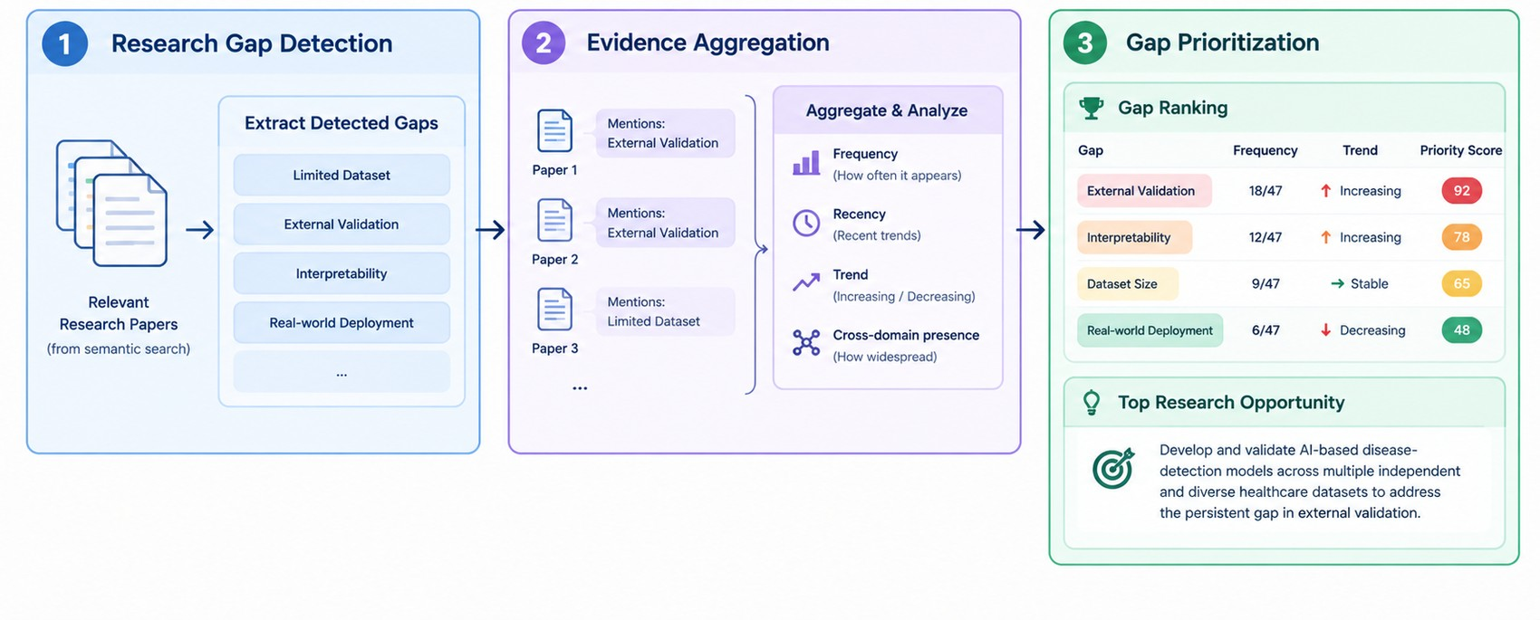
- Research gap detection, evidence aggregation, and gap prioritization (conceptual illustration; the frequencies and scores shown are illustrative only).

Recommendation and SDG Alignment
The dominant gap is mapped to a future research direction, a suggested methodology, and an expected contribution; for example, ethical concerns lead to fairness evaluation, bias analysis, explainable AI, and privacy-preserving methods, while limited external validation leads to testing on independent datasets and populations. In parallel, SDG information attached to the papers [22], [23] is counted to find the dominant SDG alignment, linking gaps to broader sustainable-development objectives (Fig. 5).
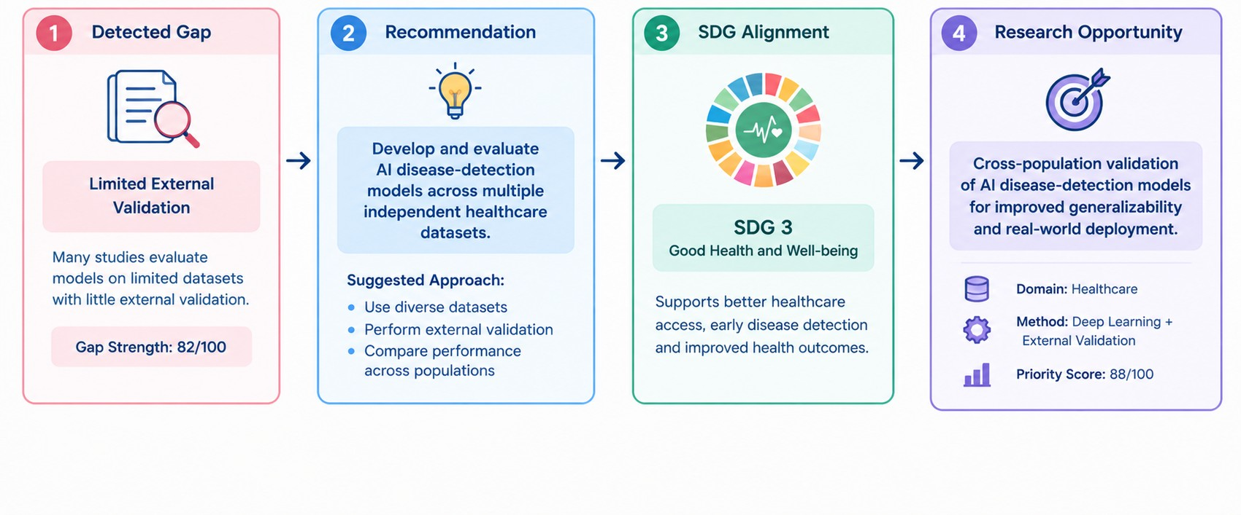
- From research gap to future research recommendation, SDG alignment, and research opportunity (conceptual illustration; the scores shown are illustrative only).

Technical Architecture
The system has four layers: a Data Layer (OpenAlex collection and structuring), an AI/NLP Layer (preprocessing and Sentence Transformer embeddings), a Search and Analysis Layer (FAISS retrieval, gap detection, aggregation, prioritization), and a Streamlit-based Application Layer [24] for searching topics and viewing papers, gaps, SDG analysis, and recommendations.

Results and Discussion
The system was demonstrated through its dashboard with the topic “AI for disease detection” and Healthcare as the target domain. The dashboard shows 2,200 papers across 10 domains.

Retrieval Results
The system retrieved 35 papers spanning 2020–2024, with the most in 2023, covering AI in healthcare, medical diagnosis, disease detection, COVID-19 applications, and machine-learning-based healthcare research (Fig. 6). Retrieval therefore reaches beyond papers containing the exact phrase “disease detection.” The top 10 are displayed by semantic similarity; the highest-ranked was “Artificial intelligence in healthcare: transforming the practice of medicine” at 57.99%, followed by “Artificial Intelligence in Healthcare: Perception and Reality” at 57.09%. Several abstracts discuss implementation, validation, ethics, and data limitations, which supply the evidence for gap analysis (Fig. 7). The relevance of these retrieved papers was not manually verified in this demonstration; the benchmark below reports manually judged relevance for five benchmark queries.
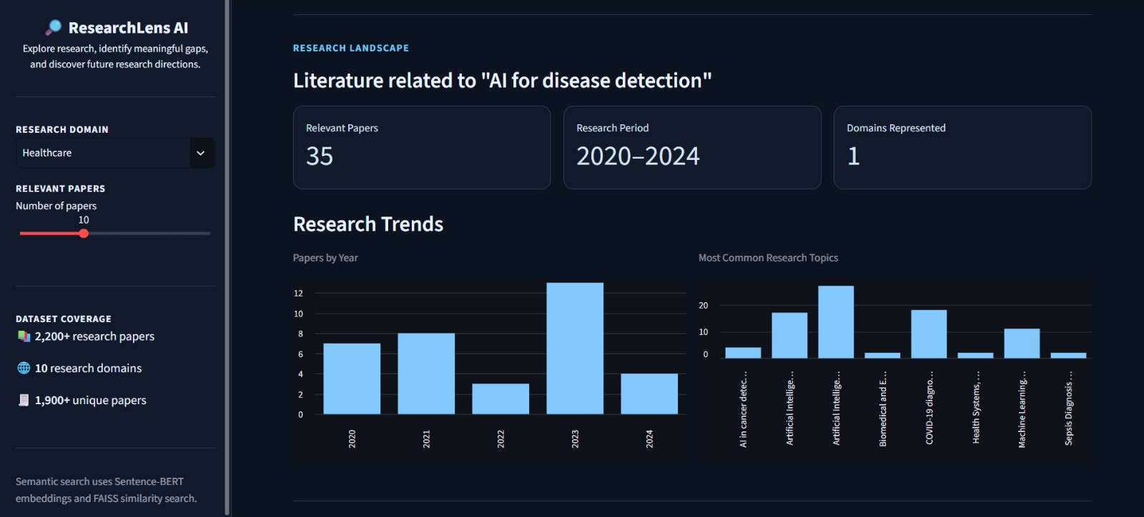
- Research landscape and temporal trends for the selected topic.
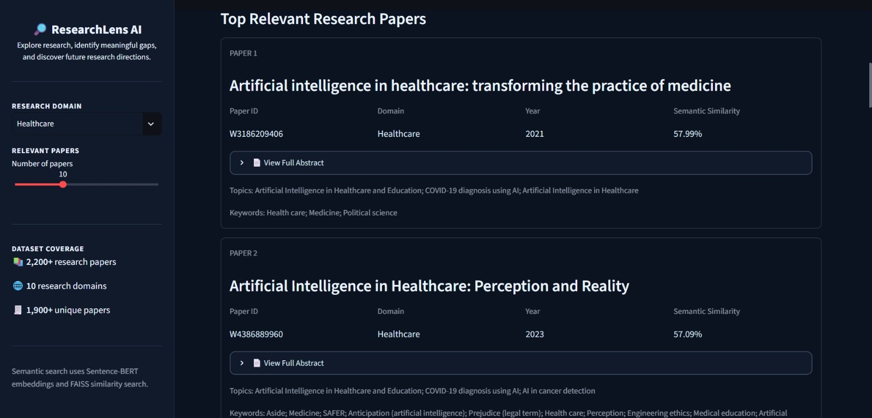
- Top semantically similar research papers retrieved by ResearchLens AI.

Retrieval Benchmark: BM25 versus Semantic Retrieval
To complement the dashboard demonstration, we compared semantic retrieval with a BM25 lexical baseline on five domain-specific queries: AI for early disease detection (Healthcare), machine learning for crop disease prediction (Agriculture), explainable AI for cybersecurity (Computer Science), AI-based personalized learning (Education), and deep learning for climate prediction (Environmental Science). For each query, both methods ranked the same domain-filtered candidate set of 220 papers and returned their top 10. Semantic ranking used the dot product of the normalized all-MiniLM-L6-v2 embeddings, computed with NumPy, not FAISS search; the application itself searches with a FAISS IndexFlatIP index. The top-10 lists of the two methods were pooled per query and deduplicated by paper ID, giving 79 unique papers, and each paper was judged relevant or not relevant manually from its title and abstract. Precision@10 is the share of relevant papers in a method’s top 10. Pooled Recall@10 is the number of relevant papers a method retrieved divided by the number of relevant papers in the pool for that query, so it is not recall over the whole corpus. F1@10 combines the two, and nDCG@10 uses binary relevance.
Table II reports the results. Mean Precision@10 over all five queries was 0.20 for BM25 and 0.26 for semantic retrieval. The pools for the cybersecurity and climate queries contained no relevant paper, and neither method returned one, so Recall, F1, and nDCG are undefined for these queries and are averaged over the remaining three. Over those three queries, mean pooled Recall@10 was 0.578 for BM25 and 0.905 for semantic retrieval, mean F1@10 was 0.415 and 0.572, and mean nDCG@10 was 0.452 and 0.753. Semantic retrieval performed better on the early-disease and crop-disease queries, whereas BM25 performed better on the personalized-learning query (Precision@10 of 0.70 versus 0.50). With only five queries, these differences are indicative and were not tested statistically.
- Retrieval Benchmark Results (Rel. = Relevant Papers in Pool; P = Precision@10; R = Pooled Recall@10)
Query | Rel. | Method | P | R | F1 | nDCG
Early disease detection | 3 | BM25 | 0.100 | 0.333 | 0.154 | 0.167
 |  | Sem. | 0.300 | 1.000 | 0.462 | 0.532
Crop disease prediction | 5 | BM25 | 0.200 | 0.400 | 0.267 | 0.228
 |  | Sem. | 0.500 | 1.000 | 0.667 | 0.938
Cybersecurity (XAI) | 0 | BM25 | 0.000 | – | – | –
 |  | Sem. | 0.000 | – | – | –
Personalized learning | 7 | BM25 | 0.700 | 1.000 | 0.824 | 0.961
 |  | Sem. | 0.500 | 0.714 | 0.588 | 0.790
Climate prediction | 0 | BM25 | 0.000 | – | – | –
 |  | Sem. | 0.000 | – | – | –
Mean |  | BM25 | 0.200 | 0.578 | 0.415 | 0.452
 |  | Sem. | 0.260 | 0.905 | 0.572 | 0.753
In Table II, “–” marks metrics that are undefined because the pool contains no relevant paper, and the mean Recall, F1, and nDCG use the three queries with at least one relevant paper. We did not analyze why BM25 performed better on the personalized-learning query, or whether the corpus contains relevant papers for the cybersecurity and climate queries; these cases are left for future work.

Research Gap Detection
Gap analysis ran on the 35 retrieved papers, not all 220 Healthcare papers. Ethical Concerns was the primary gap, described in terms of privacy, fairness, transparency, bias, and responsible AI use, but it appeared in only 1 of 35 papers, so its strength was classified as Low (Fig. 8). Resource Constraints appeared in one paper. This is a topic-specific observed limitation, not a claim that ethics is universally the largest gap in AI-based disease detection. Because the detector has not been validated, this output shows detected limitation mentions, not confirmed research gaps.
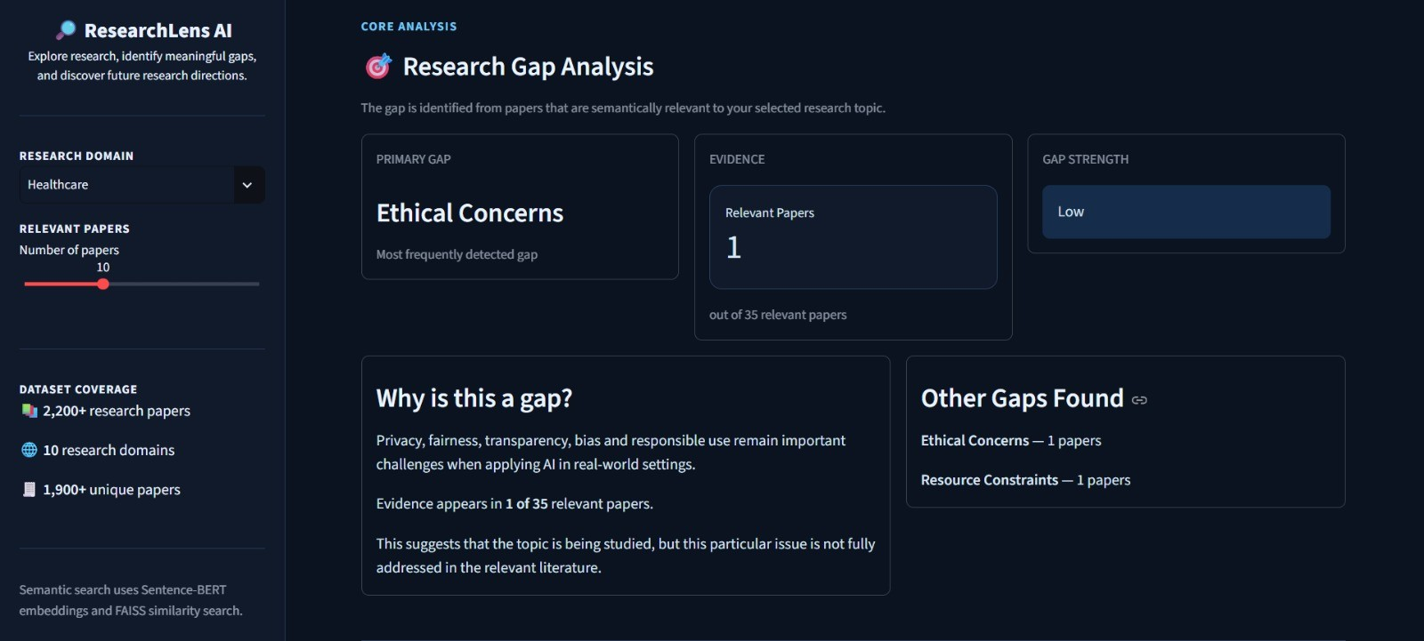
- Topic-specific research gap analysis.

SDG Alignment and Recommendation
SDG 9 (Industry, Innovation and Infrastructure) was most represented, with 5 retrieved papers, followed by SDG 3 (Good Health and Well-Being) with four, and SDGs 16, 17, 2, and 10 with one each (Fig. 9). SDG 9 reflects the technology-oriented nature of the literature, and SDG 3 its direct link to health objectives. From the dominant gap, the system recommended developing transparent, fair, and responsible AI systems, with actions to evaluate privacy risks, measure fairness and bias, improve transparency, and define responsible deployment requirements; suggested methods are fairness evaluation, privacy-preserving AI, bias analysis, and explainable AI, for more trustworthy adoption (Fig. 10). The SDG labels come from OpenAlex metadata and were not independently validated.
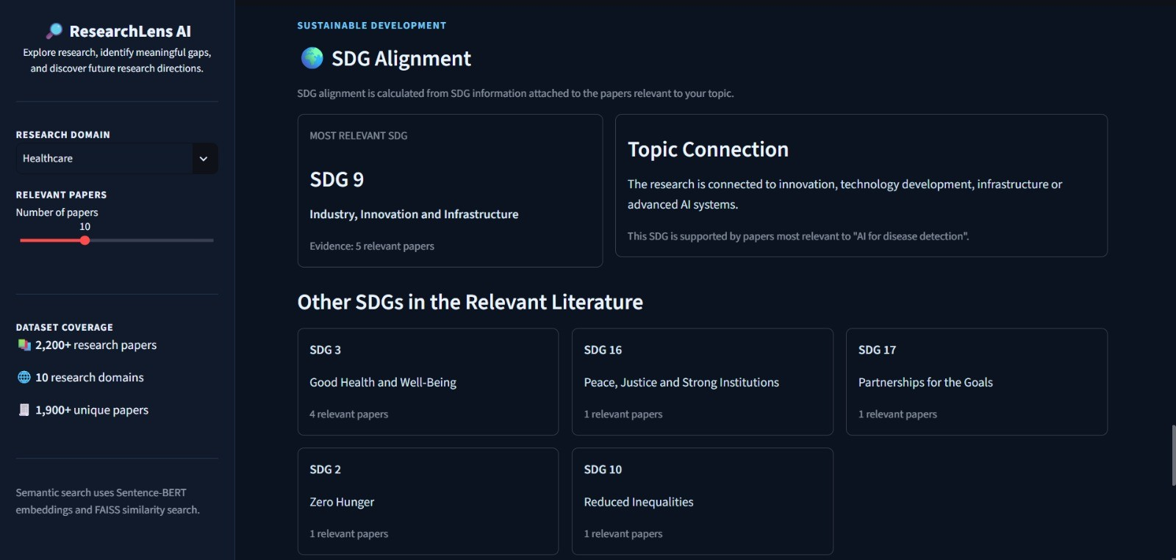
- SDG alignment of the research topic.
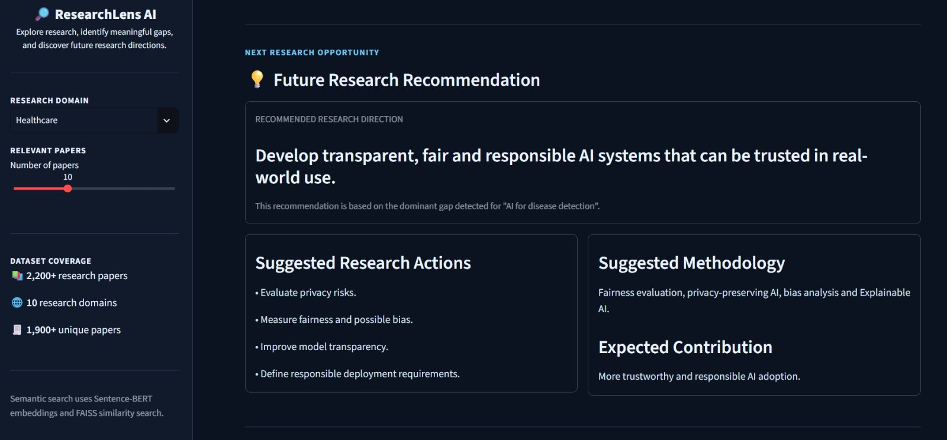
- Future research recommendation derived from the identified gap.

Discussion
Semantic retrieval built a focused set from a multi-domain corpus and captured conceptual relationships beyond exact keywords. The system reports only the evidence it detects: Ethical Concerns in one paper yields a Low strength, a more cautious reading than presenting every discussed limitation as a major gap. Retrieval, gap analysis, SDG analysis, and recommendation form one connected workflow, from a broad topic to a structured view of literature, limitations, sustainability alignment, and a next direction. The benchmark is small and its relevance labels have limited documentation, so it supports only a cautious reading: semantic retrieval returned more relevant papers on two of the three queries in which any relevant paper existed, whereas lexical matching remained competitive and was better on one.

Limitations
The current implementation has several limitations.
- Limited corpus: 2,200 OpenAlex papers across 10 domains cannot represent all literature, so relevant studies may be missing and retrieved results and gaps may be incomplete.
- Semantic retrieval: similarity does not guarantee relevance; results depend on query wording, paper metadata, and the embedding model, so retrieved papers may need further review.
- Rule-based gap detection: predefined patterns may miss gaps described indirectly or flag phrase matches that are not genuine limitations in context, so the module is an aid rather than full understanding. It has not been validated against human annotations, so a detected limitation mention should not be read as a confirmed research gap.
- Dependence on retrieved evidence: a gap supported by few papers gets low strength, and a frequent gap is not necessarily the most novel one; the Low strength of Ethical Concerns reflects available evidence, not unimportance.
- Recommendations and SDG metadata: recommendations rely on predefined mappings and need review, and SDG alignment depends on the quality of the attached metadata rather than expert assessment. Also, 783 of the 2,200 papers (35.6%) have no SDG label.
- Evaluation: the retrieval benchmark uses five queries and 79 pooled papers, so its differences are indicative and were not tested statistically. Relevance was judged manually from titles and abstracts; the annotators’ identities and the adjudication procedure were not recorded, the BM25-only papers did not receive a second review, and no inter-annotator agreement could be computed. Gap detection and recommendations have not been validated against human annotations. The benchmark computed semantic similarity with NumPy rather than FAISS, and no runtime comparison is reported.
Outputs should be treated as evidence-based preliminary insights that assist, rather than replace, critical reading, expert judgment, and independent verification.

Conclusion and Future Scope
This paper presented ResearchLens AI, which takes a research topic to retrieved literature, rule-based limitation signals, SDG labels from OpenAlex metadata, and predefined future-direction recommendations in one interface, using 2,200 OpenAlex papers, all-MiniLM-L6-v2 embeddings, FAISS retrieval, and a Streamlit dashboard. In a small benchmark of five queries, semantic retrieval reached a mean Precision@10 of 0.26 against 0.20 for BM25, and a mean pooled Recall@10 of 0.905 against 0.578 over the three queries with relevant papers, but BM25 was better on one query and neither method found relevant papers for two. The limitation detector, the recommendations, and the SDG labels were not validated, so these results show a working workflow and a preliminary retrieval comparison, not a validated gap-identification system.
Future work will focus on the following improvements.
- Corpus expansion: more OpenAlex papers and additional reliable academic sources, kept up to date and free of duplicate or incomplete entries.
- Better gap detection: context-aware NLP or trained classifiers that read methodology, results, and limitations sections, validated against manually annotated papers.
- Larger evaluation: more queries, documented independent double annotation with agreement statistics, and expert-annotated data for validating gap detection and recommendations.
- Persistence, graph, and novelty models: a gap persistence and prioritization model over publication years, and knowledge graph relationships with novelty scoring; neither is part of the current implementation.
- Richer outputs: more specific, evidence-linked recommendations, content-based SDG validation, and detailed temporal and cross-domain trend analysis.
These steps could evolve ResearchLens AI from a research discovery prototype into a validated research analysis and decision-support system.

References
- V. Gopalakrishnan, K. Jha, W. Jin, and A. Zhang, “A survey on literature based discovery approaches in biomedical domain,” Journal of Biomedical Informatics, vol. 93, Art. no. 103141, 2019, doi: 10.1016/j.jbi.2019.103141.
- O. Dewidar et al., “Frameworks to identify research gaps, frame research needs, and derive research priorities from evidence syntheses: A scoping review,” Journal of Clinical Epidemiology, vol. 197, Art. no. 112342, 2026, doi: 10.1016/j.jclinepi.2026.112342.
- L. Nyanchoka, C. Tudur-Smith, V. N. Thu, V. Iversen, A. C. Tricco, and R. Porcher, “A scoping review describes methods used to identify, prioritize and display gaps in health research,” Journal of Clinical Epidemiology, vol. 109, pp. 99–110, 2019, doi: 10.1016/j.jclinepi.2019.01.005.
- D. N. Nicholson and C. S. Greene, “Constructing knowledge graphs and their biomedical applications,” Computational and Structural Biotechnology Journal, vol. 18, pp. 1414–1428, Jan. 2020.
- A. Hogan et al., Knowledge Graphs, Synthesis Lectures on Data, Semantics, and Knowledge. Cham, Switzerland: Springer, 2022.
- J. Lajus and F. M. Suchanek, “Are all people married?: Determining obligatory attributes in knowledge bases,” in Proc. World Wide Web Conf. (WWW), 2018, pp. 1115–1124.
- Y. Lu, W. Wu, X. Zhao, R. Peng, and J. Wang, “KARMA: Leveraging multi-agent LLMs for automated knowledge graph enrichment,” arXiv preprint arXiv:2502.06472, 2025.
- A. Godinez, “HySemRAG: A hybrid semantic retrieval-augmented generation framework for automated literature synthesis and methodological gap analysis,” arXiv preprint arXiv:2508.05666, 2025.
- L. Joos, D. A. Keim, and M. T. Fischer, “Cutting through the clutter: The potential of LLMs for efficient filtration in systematic literature reviews,” in Proc. EuroVis Workshop on Visual Analytics (EuroVA), Eurographics Association, 2025, doi: 10.2312/eurova.20251105.
- S. Agarwal et al., “LitLLM: A toolkit for scientific literature review,” arXiv preprint arXiv:2402.01788, 2024.
- M. F. M. Chowdhury, G. Rossiello, M. Glass, N. Mihindukulasooriya, and A. Gliozzo, “Applying a generic sequence-to-sequence model for simple and effective keyphrase generation,” arXiv preprint arXiv:2201.05302, 2022.
- T. Erekhinskaya, M. Balakrishna, M. Tatu, S. Werner, and D. Moldovan, “Knowledge extraction for literature review,” in Proc. ACM/IEEE Joint Conf. Digital Libraries, 2016, pp. 221–222.
- R. van Dinter, B. Tekinerdogan, and C. Catal, “Automation of systematic literature reviews: A systematic literature review,” Information and Software Technology, vol. 136, Art. no. 106589, Aug. 2021, doi: 10.1016/j.infsof.2021.106589.
- A. M. Sami et al., “System for systematic literature review using multiple AI agents: Concept and an empirical evaluation,” arXiv preprint arXiv:2403.08399, 2024.
- R. Silva, B. Lemos, B. Falcucci, and G. Maia, “A multi-agent system for detection and prioritization of research gaps in scientific literature,” in Proc. Workshop-Escola de Sistemas de Agentes, seus Ambientes e Aplicações (WESAAC), Cuiabá, Brazil, 2026. [Online]. Available: https://sol.sbc.org.br/index.php/wesaac/article/view/45243. [Accessed: Oct. 27, 2026].
- Z. He et al., “AgentsCourt: Building judicial decision-making agents with court debate simulation and legal knowledge augmentation,” arXiv preprint arXiv:2403.02959, 2024, doi: 10.18653/v1/2024.findings-emnlp.549.
- J. Priem, H. Piwowar, and R. Orr, “OpenAlex: A fully-open index of scholarly works, authors, venues, institutions, and concepts,” arXiv preprint arXiv:2205.01833, 2022. [Online]. Available: https://arxiv.org/abs/2205.01833
- OpenAlex, “API reference,” OpenAlex Help Center. [Online]. Available: https://help.openalex.org/api/. [Accessed: Oct. 14, 2026].
- N. Reimers and I. Gurevych, “Sentence-BERT: Sentence embeddings using Siamese BERT-networks,” in Proc. 2019 Conf. Empirical Methods in Natural Language Processing and 9th Int. Joint Conf. Natural Language Processing (EMNLP-IJCNLP), Hong Kong, China, 2019, pp. 3982–3992, doi: 10.18653/v1/D19-1410.
- Sentence Transformers, “all-MiniLM-L6-v2,” Hugging Face Model Repository. [Online]. Available: https://huggingface.co/sentence-transformers/all-MiniLM-L6-v2. [Accessed: Oct. 14, 2026].
- M. Douze et al., “The Faiss library,” arXiv preprint arXiv:2401.08281, 2024, doi: 10.48550/arXiv.2401.08281.
- United Nations General Assembly, “Transforming our world: The 2030 Agenda for Sustainable Development,” Resolution A/RES/70/1, Sep. 25, 2015. [Online]. Available: https://sdgs.un.org/2030agenda
- OpenAlex, “Sustainable Development Goals (SDGs),” OpenAlex Help Center. [Online]. Available: https://help.openalex.org/data/sdgs/. [Accessed: Oct. 14, 2026].
- Streamlit, “Streamlit documentation.” [Online]. Available: https://docs.streamlit.io/. [Accessed: Oct. 14, 2026].

